NAME: SHAIK MOHAMMAD IRFAN
REG NO :192472190

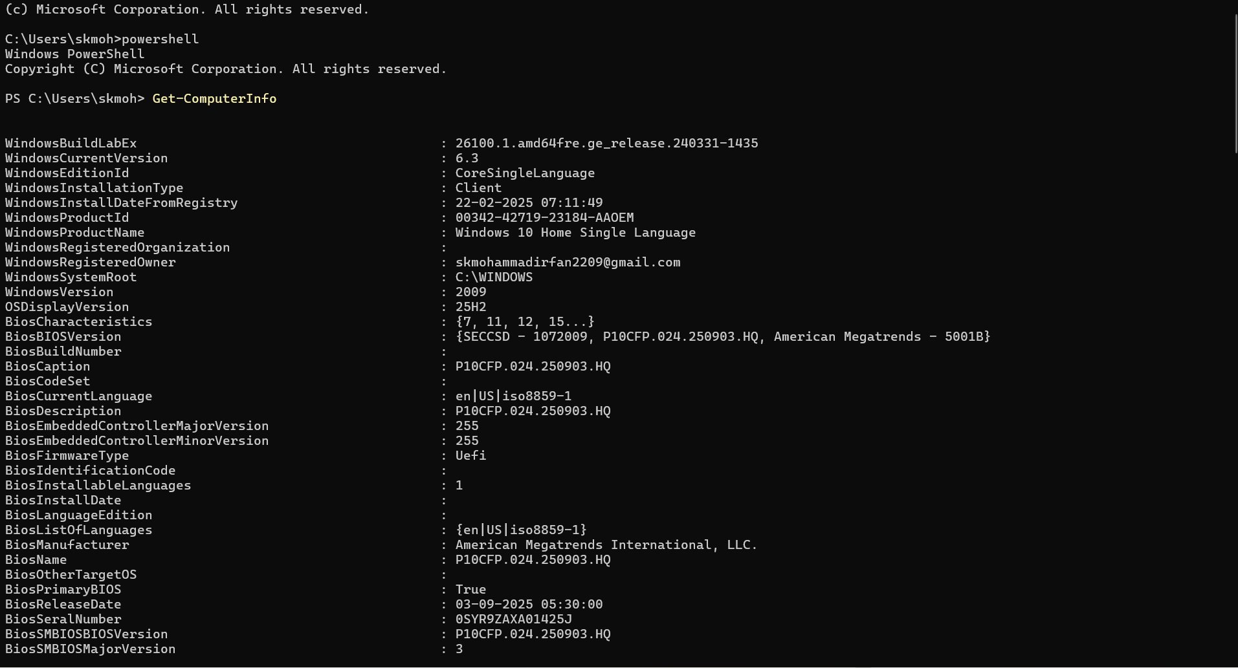

Physical disks

Disk volumes

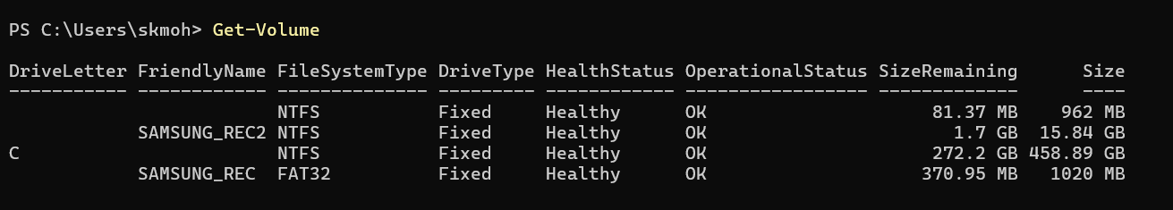

Disk partitions:

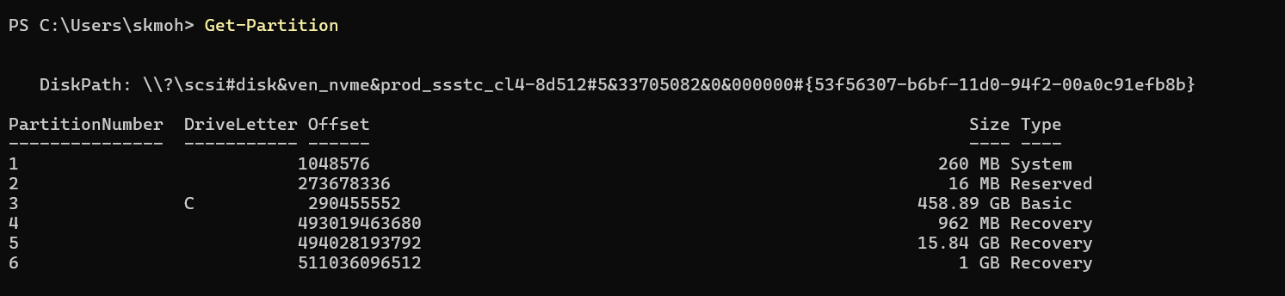

IP addresses:

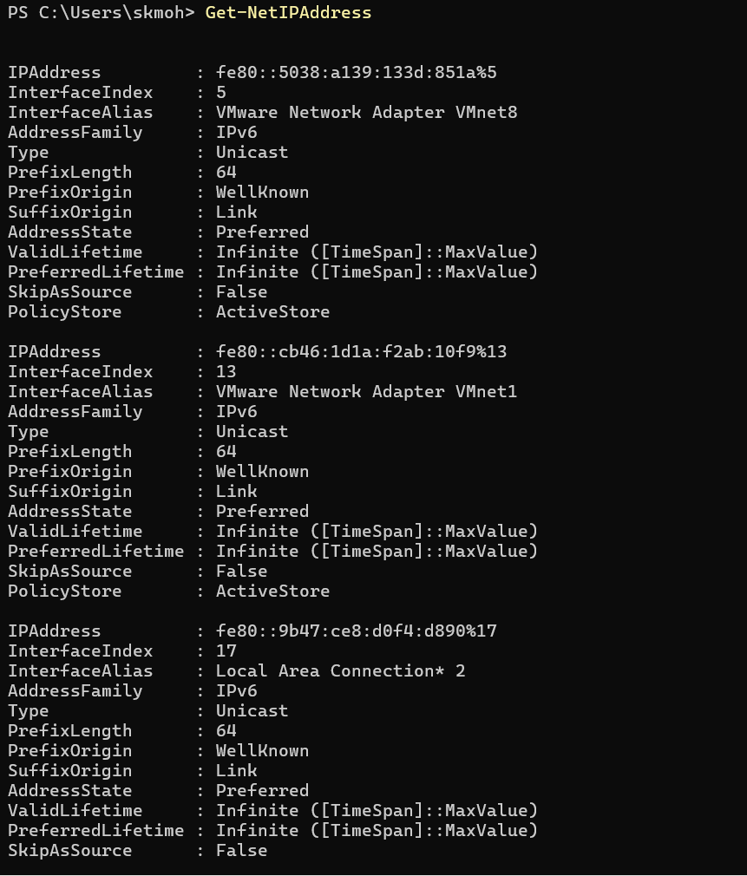

Complete IP configuration:

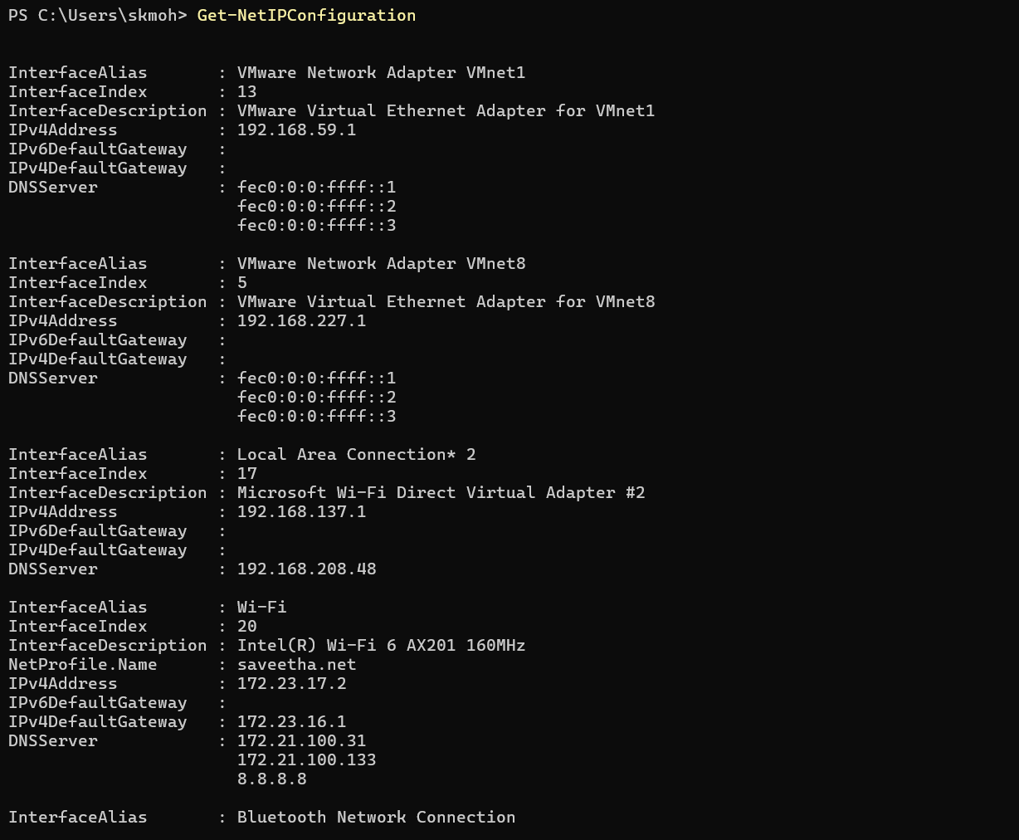

Network adapters:

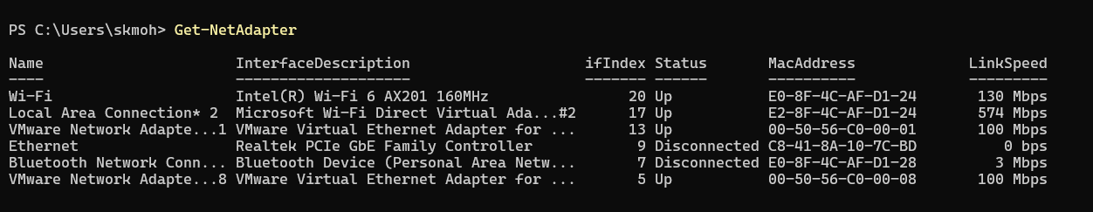

Routing table

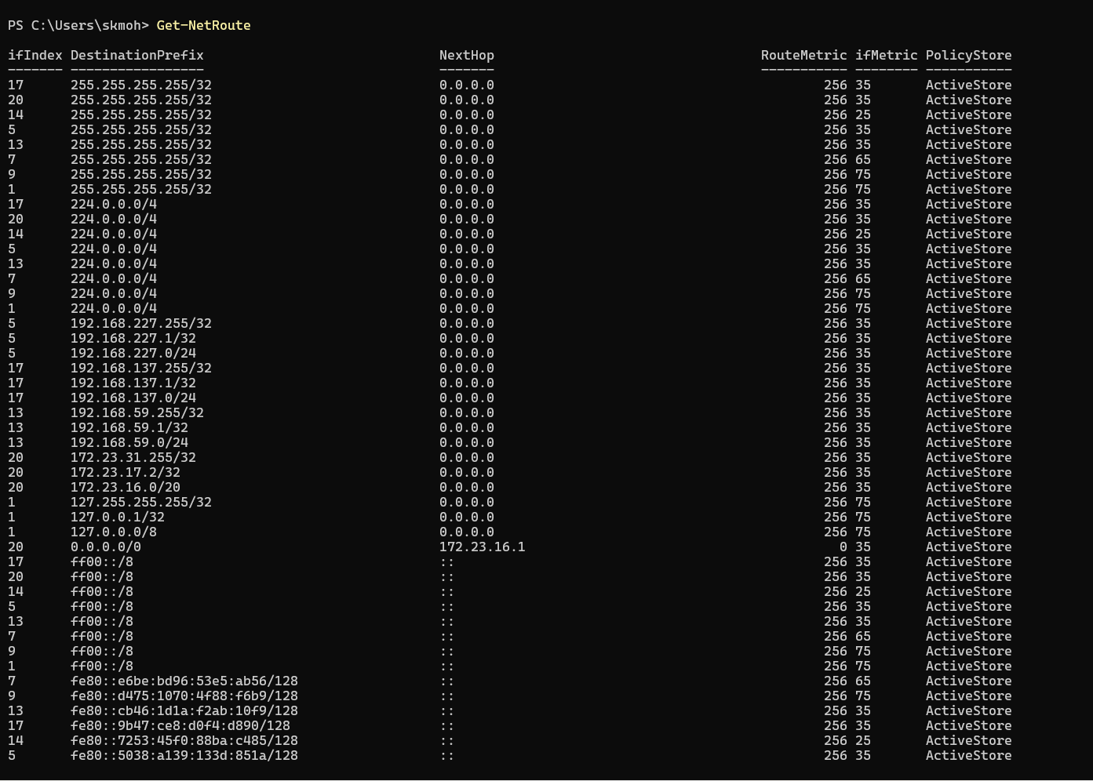

Environment variables

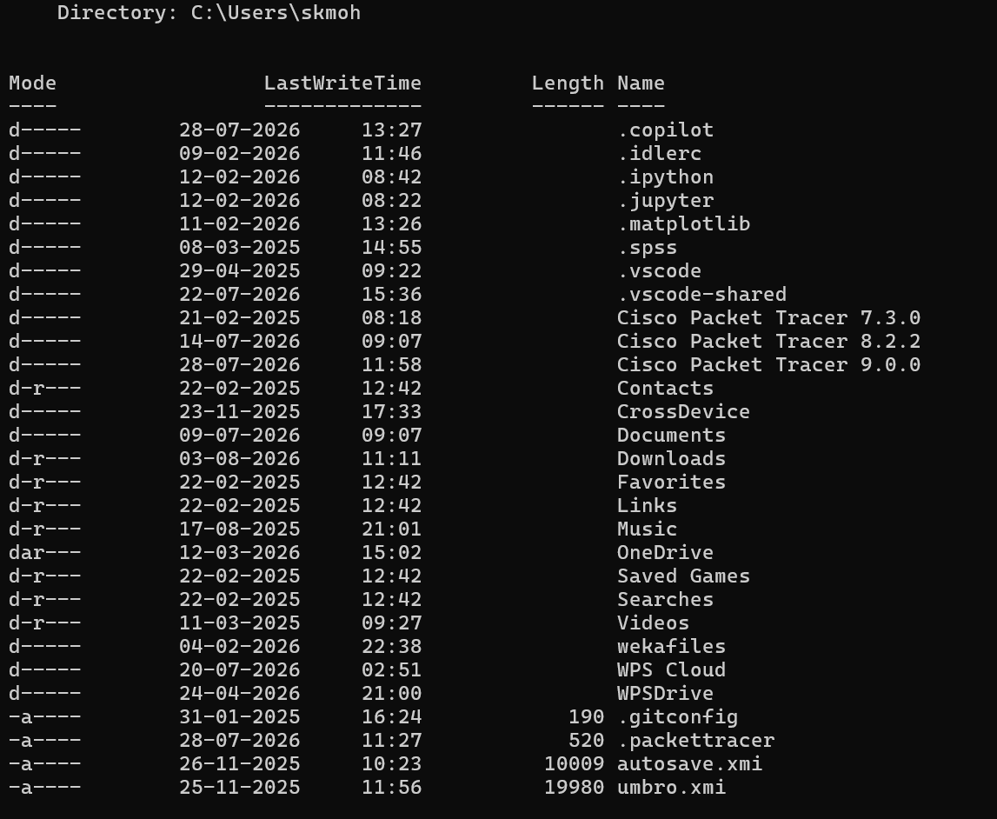

Computer name

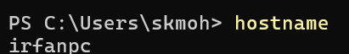

Current logged-in user

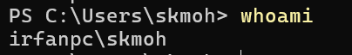

Routing table

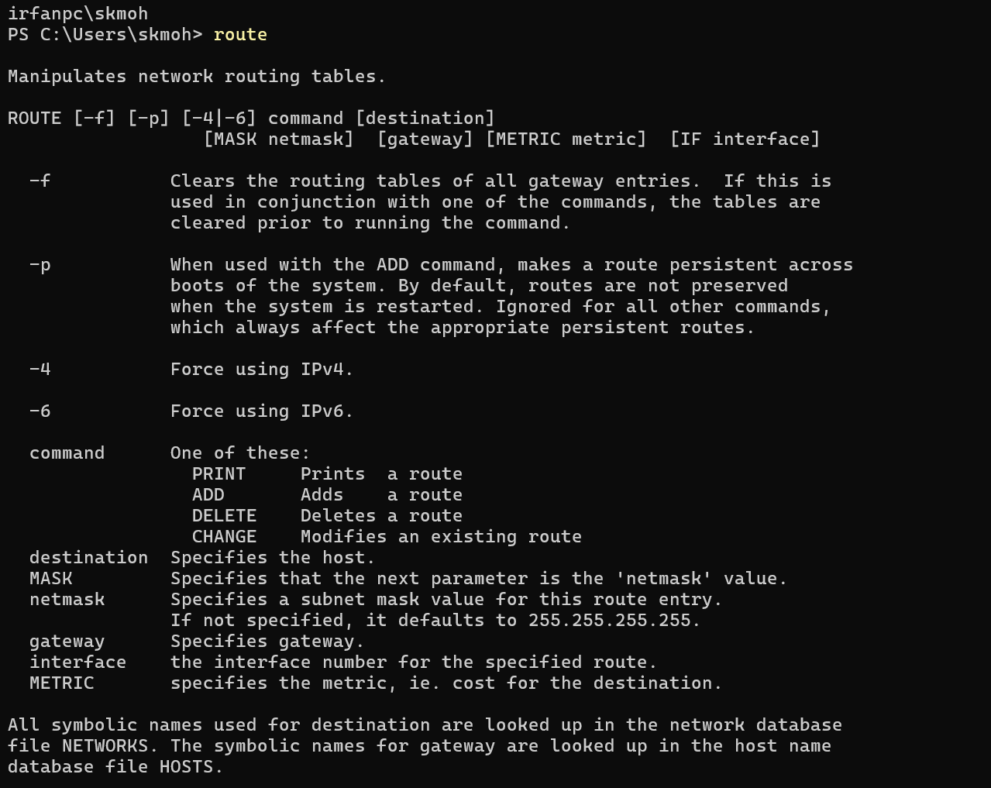

Active network connections with PIDs

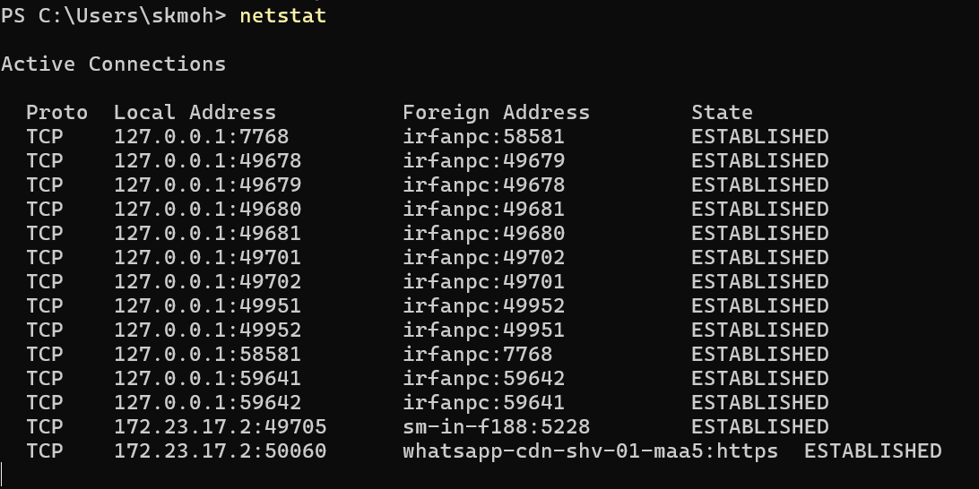

Installed device drivers

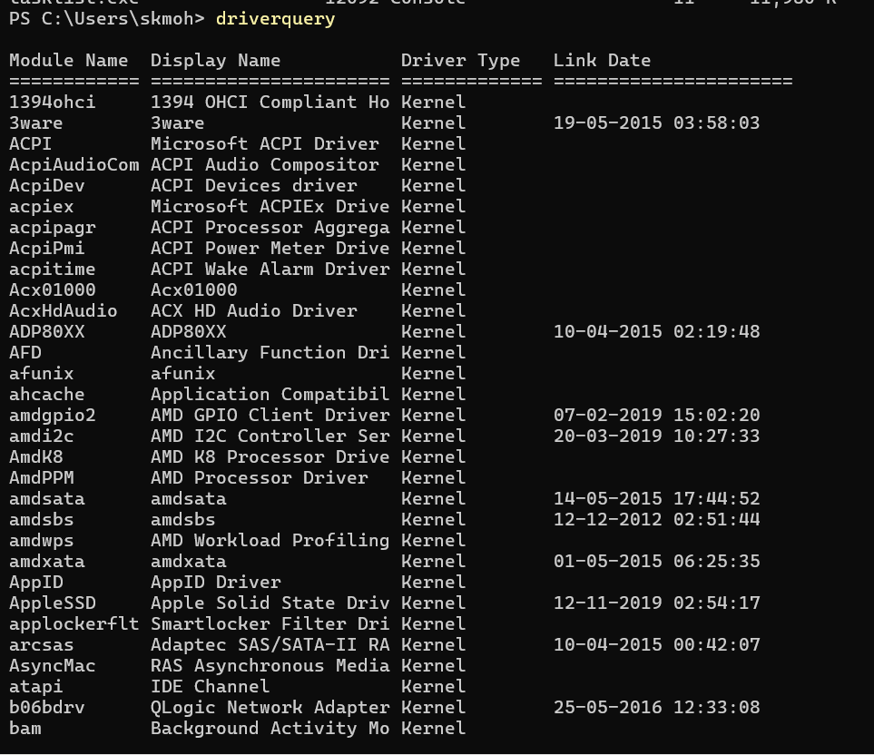

Current date and time

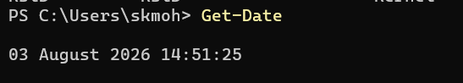

PowerShell command history

